# PROJECT MEMBERS:

* Shakeib – e – Shaida (Project coordinator)
* Tehreem Fahim
* Muslima Ilyas

# PROJECT:

Blood banks management system.

# WHAT IS OUR PROJECT?

We are making blood bank management system.

## OBJECTIVE:

The main objective of our system is that suppose you are new to the city, and an emergency occurred and you don’t know any blood banks in the city.

So our aim is to manage and centralize all the data of all the blood banks in the city, so user can just use an app and search for the nearest blood bank just by area name or postal code and get the blood from there is they have the availability.

# WHAT OTHERS HAVE DONE:

As far as what others have done is considered, in Pakistan there has been no project done like this before. In Pakistan all the blood banks manage their data separately and it decentralized.

The very big problem because of it is that the time consuming process during emergency.

But I have found one project which resembles mine and it is being managed by Indian government.

## What they have done:

They have done the same job that we want to do.

Following are the concise conclusion of the features of their project:

* User can register
* User can search all the blood banks with respect to area
* User can see the blood availability of the selected blood bank
* User can register as a donor
* User can ask for blood bottles
* Admin can manage the data of the blood banks.

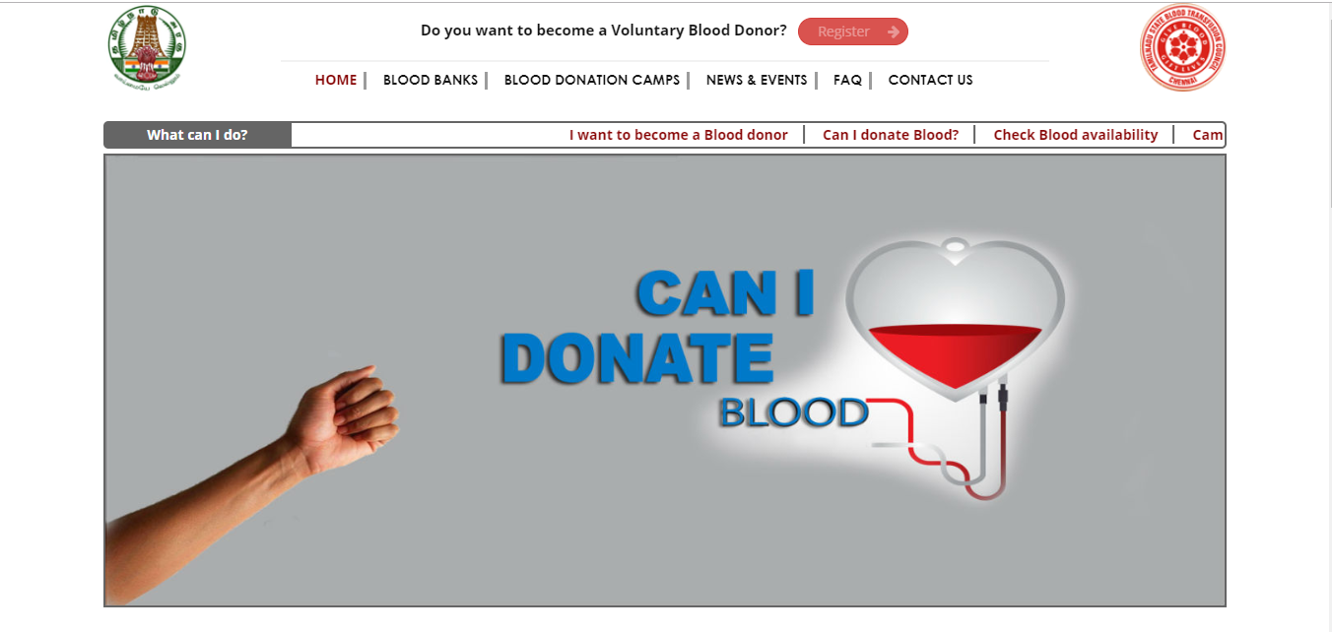

# MODULES:

The functionality of our project is divided into two modules basically:

* Admin
* User

# ALGORITHIMS:

Following are the algorithms we will use:

* Binary search (as user can search for the blood bank just by postal code)
* Basic logics to retrieve data and to insert data in the database

# METHODOLOGIES:

We will use following methodologies and technologies in our project:

* C#
* Visual Studio 2015
* Microsoft SQL Server 2012
* Microsoft SQL Server Management Studio
* Windows form
* SQL
* ADO.NET Framework

# RESOURCES AND TOOLS AVAILABLE:

Well our project can be made also as a web based application.

Tools available are:

* HTML
* CSS
* ASP.NET
* Node.JS
* JavaScript
* Other databases

# EVALUATION:

Our system looks like this:

## Screenshot:

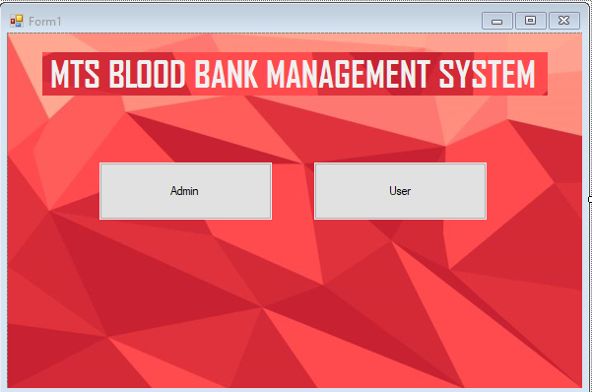

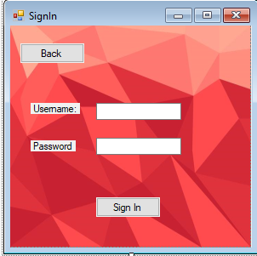

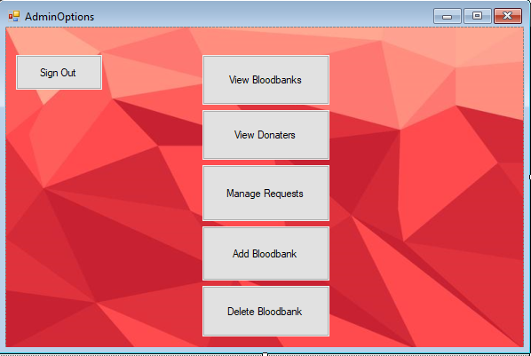

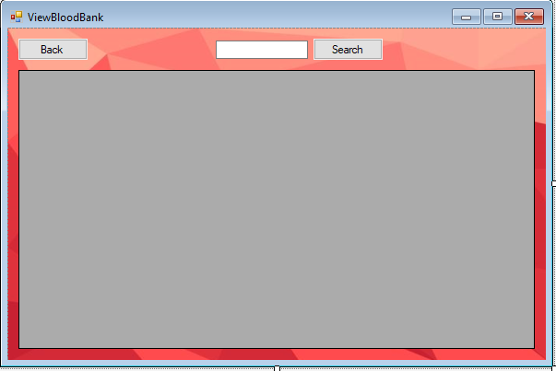

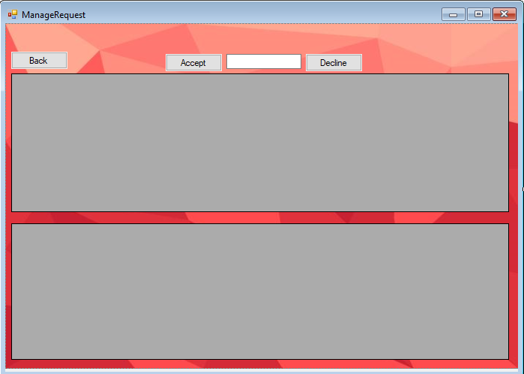

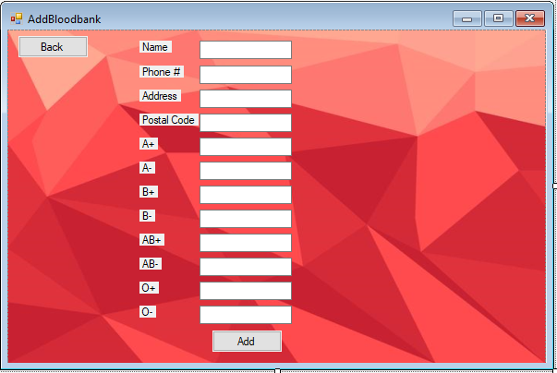

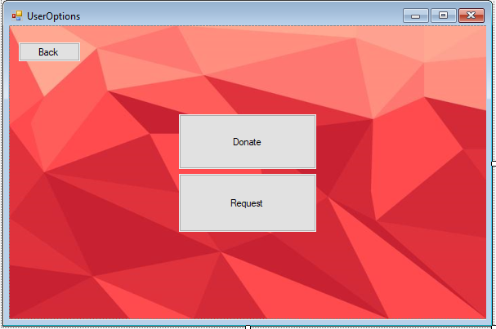

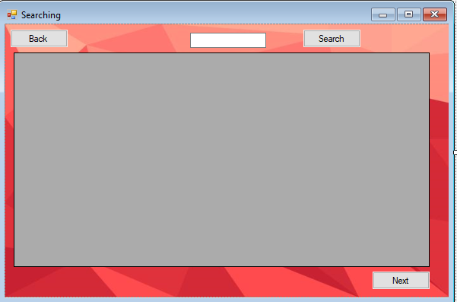

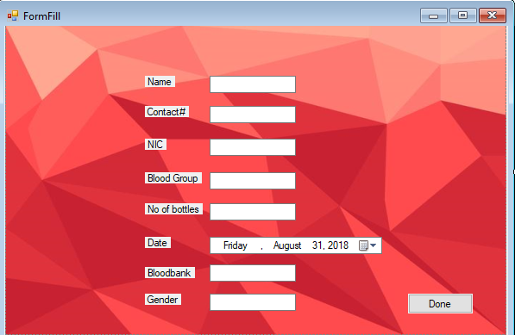

# RELAVANT LINKS AND ARITCLES:

(Scribd link for the article for the conventional blood bank management system)

<https://www.scribd.com/document/335504708/BLOOD-BANK-MANAGEMENT-SYSTEM-PROJECT-REPORT-docx>

(Sciene direct link for the article for the blood bank management system)

<https://www.sciencedirect.com/science/article/pii/S1877042815036940>

(Indian government online web application for centralized blood bank management system)

<http://www.tngovbloodbank.in/blood-bank.php>